VS Code Link - https://code.visualstudio.com/download
Git Bash Link - https://git-scm.com/downloads
Zoom Link: https://zoom.us/download

MingW Compiler - https://drive.google.com/file/d/1aC9xQL2J1JSMT-ChEd2DP4OR4es5FSjq/view?usp=sharing

Settings.json for windows- https://docs.google.com/document/d/1cxFvTnr9TbuhRU7hthAVlhA928wybyYEQJOaBFKd_sc/edit?usp=sharing

Setting.json for mac-
https://docs.google.com/document/d/1sbI7j9qRqCtVHmpBewzO613WjOiwE8Nh3QhNiGvn-64/edit?usp=sharing

Code Link: https://ideone.com/g1kF69

//code-1 => Paste it and run the code; you will see the result.
#include<stdio.h>
int main(){
printf("Hello world!");
return 0;

}

//code-2 => Paste it and run the code; take input, and then you will see the result
#include<stdio.h>
int main(){
int a;
scanf("%d",&a);
printf("a = %d",a);
return 0;

}

Shortcut Key:
Operation | Command
Copy | Ctrl + C
Paste | Ctrl + V
All select | Ctrl + A
Command Prompt | 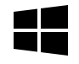+ R,then type cmd → Press Enter

Extension 1:
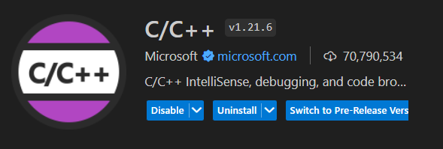
Extension 2:
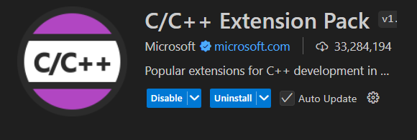

Extension 3:
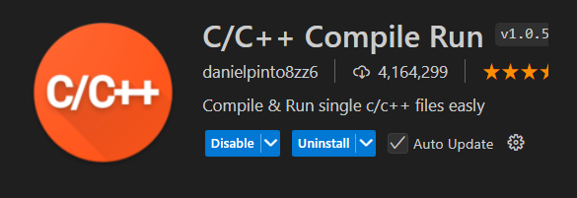
Extension 4:
